**Guidelines for the Xampp Setup**

**Step 1: Download:**

Download the latest version of Xampp as per the windows OS

**Step 2: Run .exe file:**

After the download, run the .exe file by double clicking on the file.

**Step 3: Start the setup wizard**

After running the .exe file then the start setup wizard will appear automatically. Then click on ‘Next’ to configure the installation.

**Step 4: Choose software components.**

After clicking on the ‘Next’, then the selection of the component is available and we recommend you to install all the available component for the full services.

**Step 5: Choose the installation directory**

Select the directory /C for the installation file.

**Step 6: Start the installation process.**

The installation process is forwarded and it can take several minutes to complete.

**Step 7: Complete Installation**

After unpacking all the components, the installation will be completed by clicking on the ‘Finish’ button and Xampp is good to go.

**After, Installation.**

1. Open shell from Xampp and type php –v for viewing version it will show 64.
2. After this, Go to Windows C/Xampp/php and look for php.ini, open with sublime or any editor and delete ; (semicolon) from line 934,935.

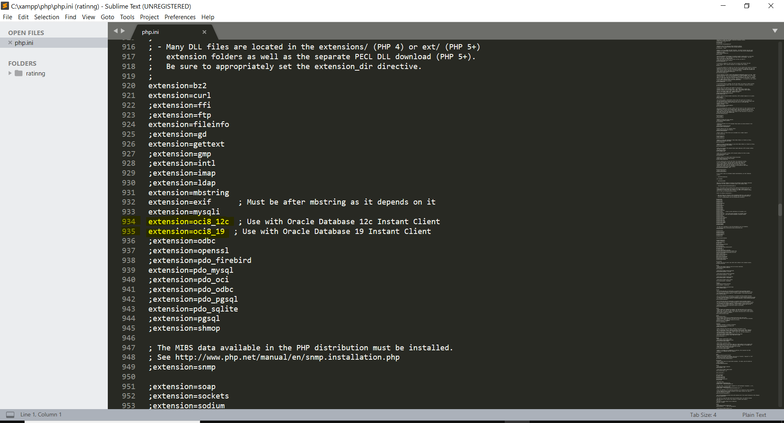

1. We have folder named php_oci8-3.0.1-8.0-ts-vs16-x64 and extract it. And copy all the .dll files to C/Xampp/php/ext.

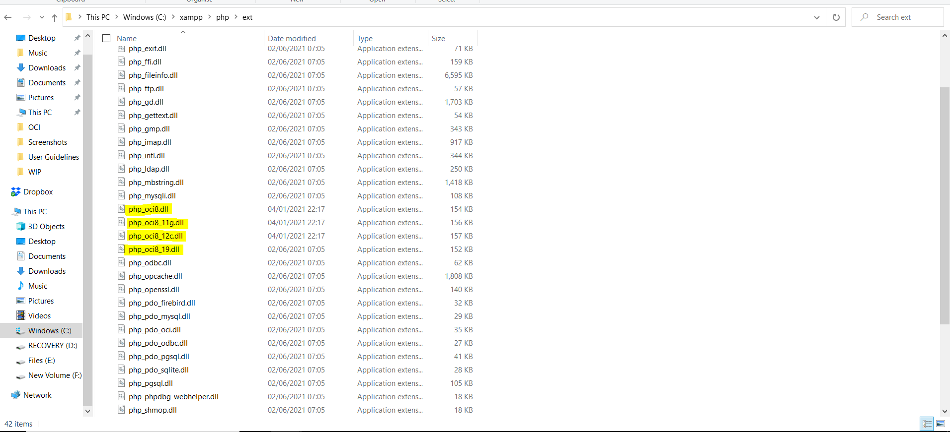

1. After that, Go to your Control Panel, look for System and Security and click on System. You will find Advanced System settings just as below

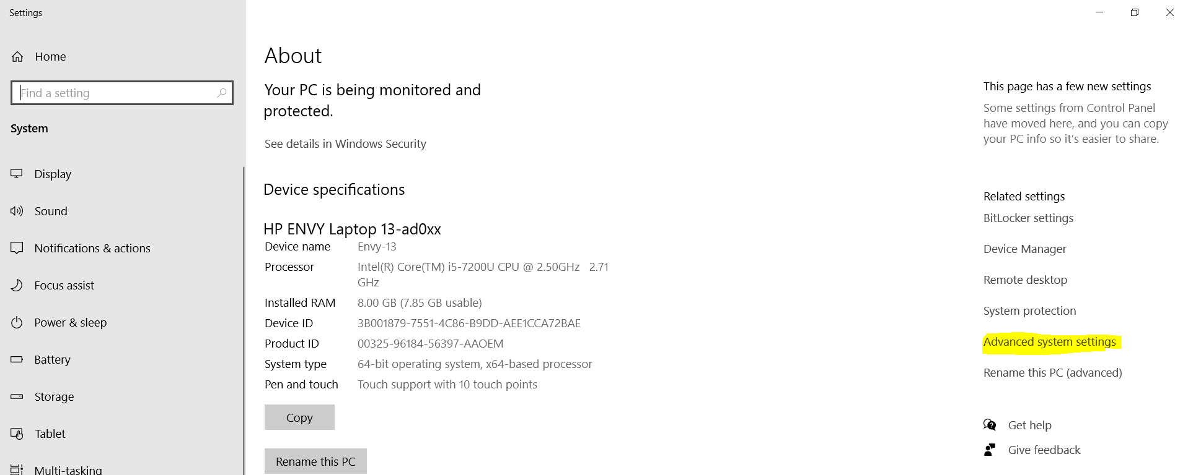

1. Click on Environment Variables

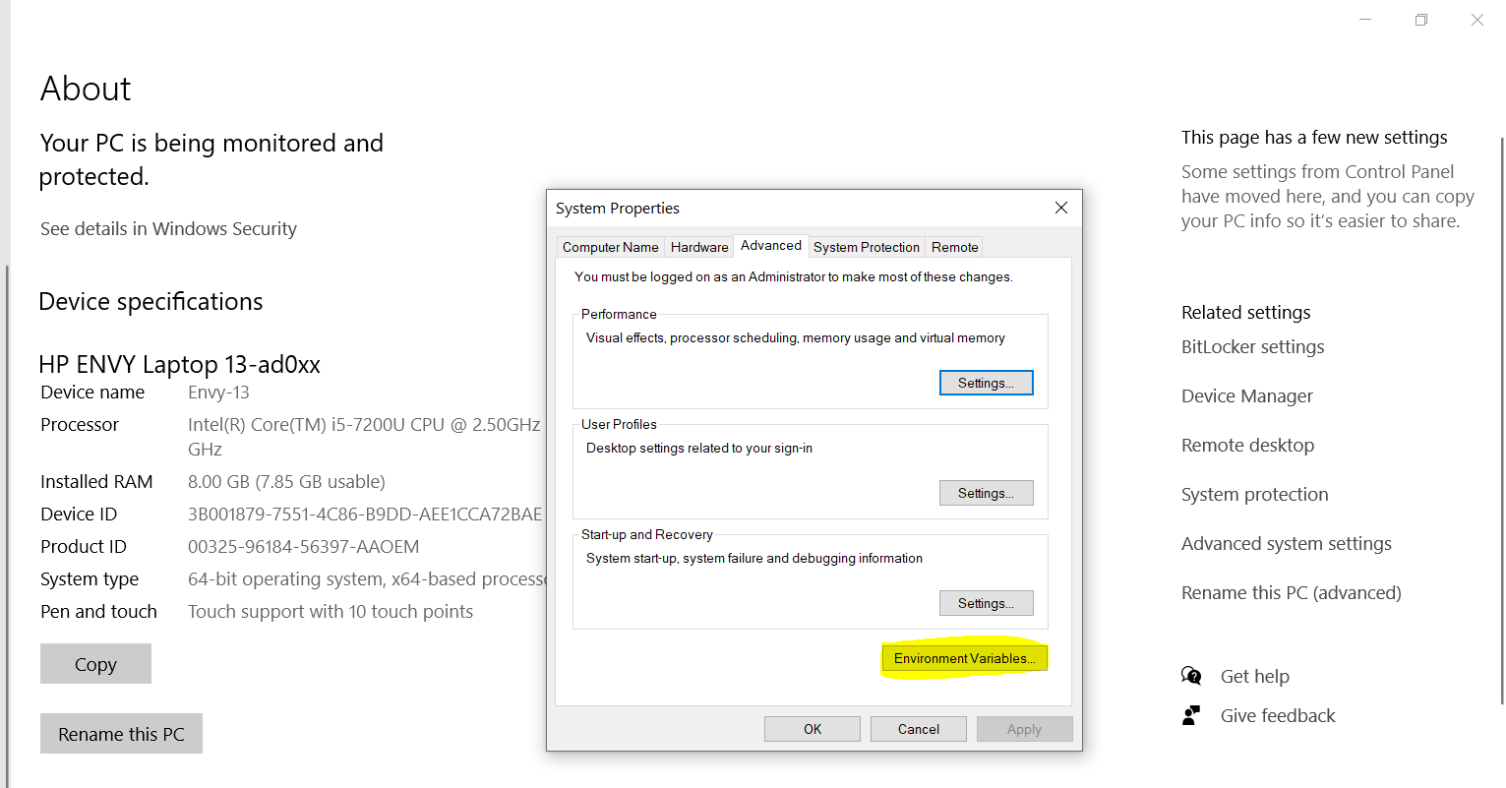

1. After clicking on Environment variables, Find Path

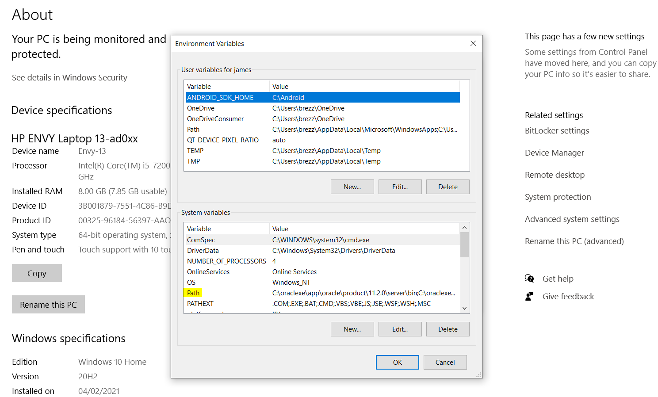

1. In path, create new and Copy this path (C:\Xampp\php) (C:\instantclient_19_11) and click Ok.

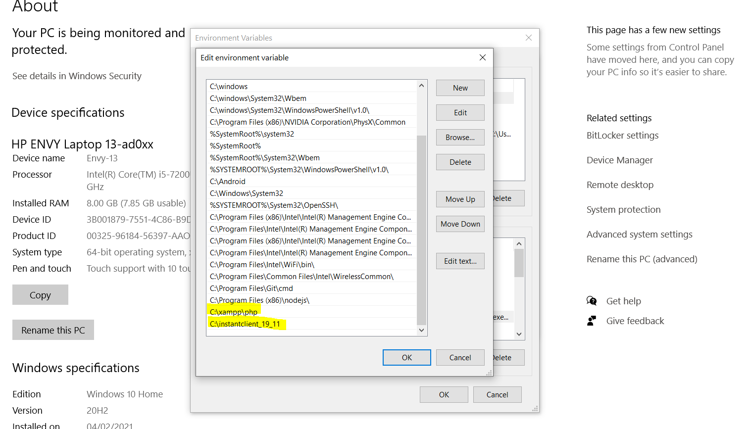

1. Restart your PC and Open shell and type php-info. It will looks alike

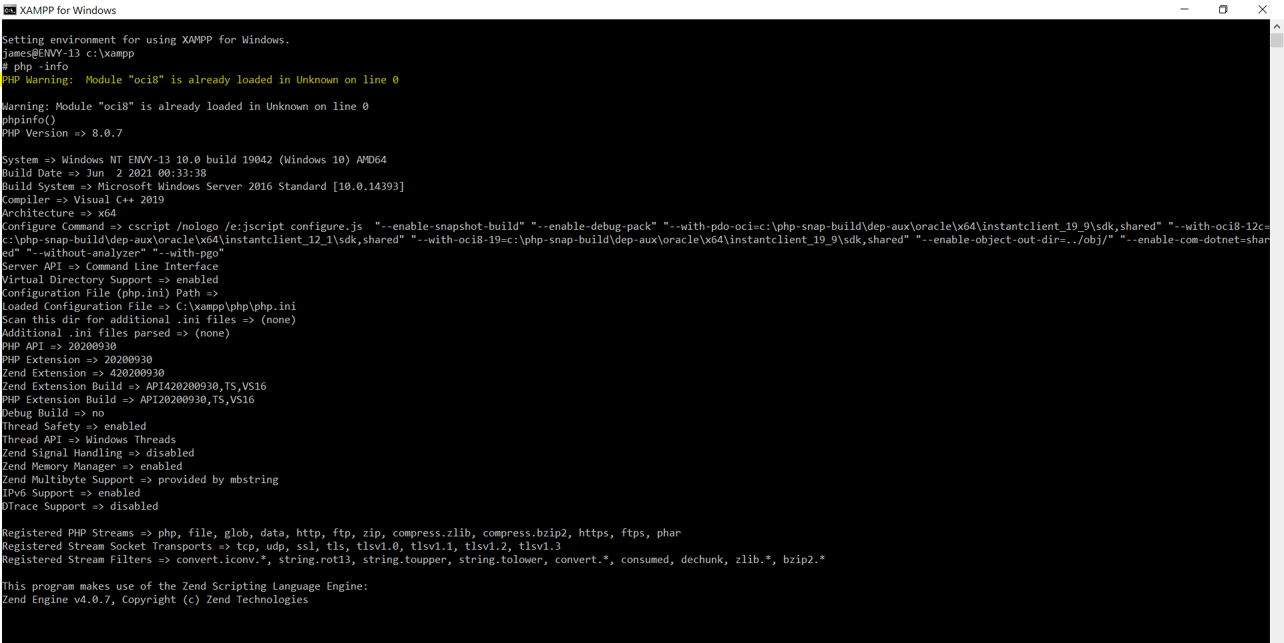

1. Now, Oci8 is enabled in your system.